1. Introduction 2

1-1. VBA 2

1-1-1. Visual Basic for Application 2

WPF Basic Data Binding FAQ

<https://blogs.msdn.microsoft.com/wpfsdk/2006/10/19/wpf-basic-data-binding-faq/>

<https://msdn.microsoft.com/en-us/library/ms752347(v=vs.110).aspx>

http://www.cnblogs.com/zhili/p/WPFBinding.html

# Assembly 和 DLL

PresentationFramework.dll

namespace System.Windows.Data

# 主要数据结构定义

## Bing

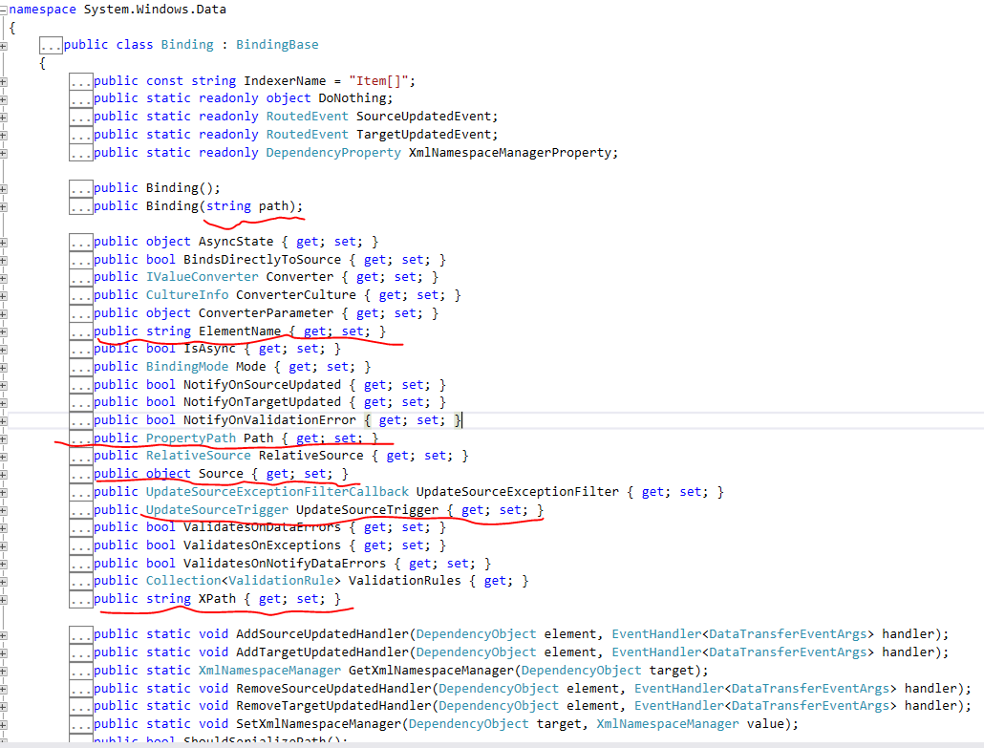

### BingingBase

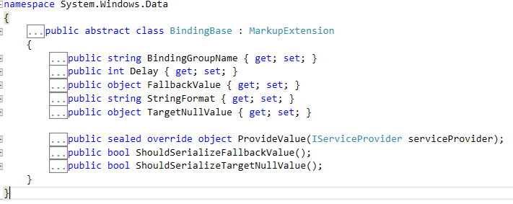

### MarkupExtension

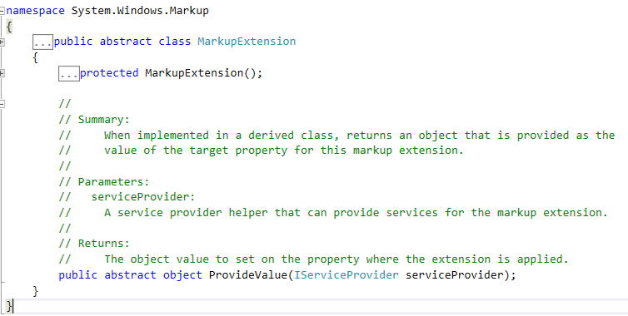

## UpdateSourceTrigger

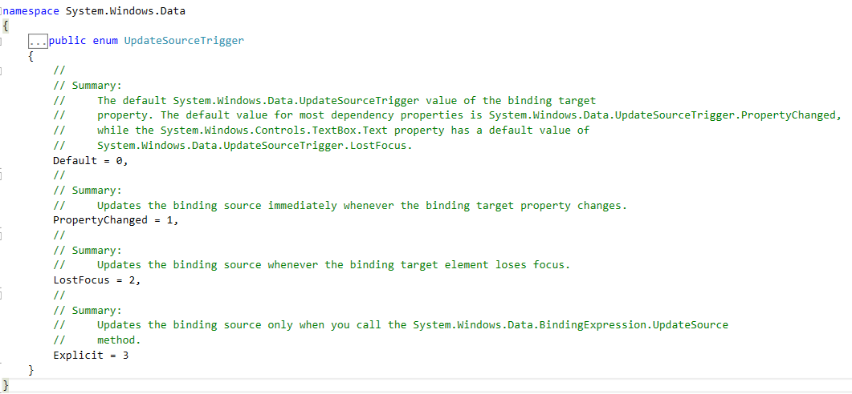

## BindingExpression

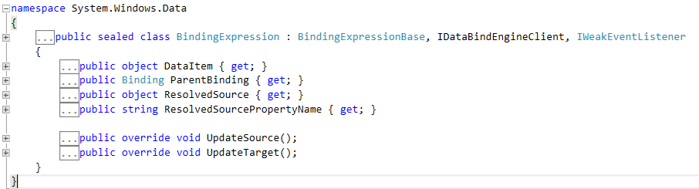

### BindExpressionBase

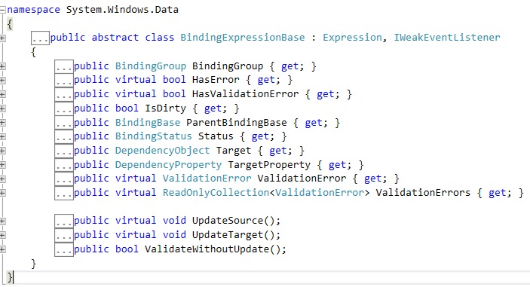

## BindingGroup

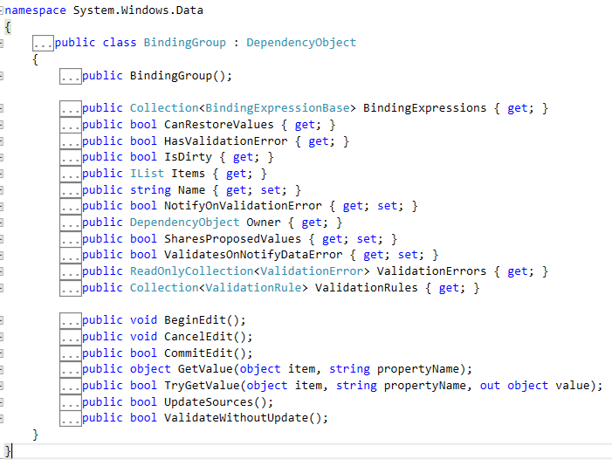

## BindingMode

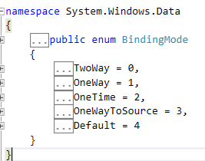

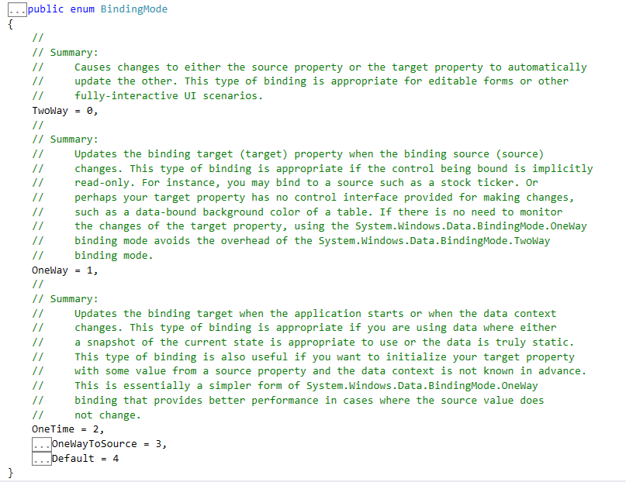

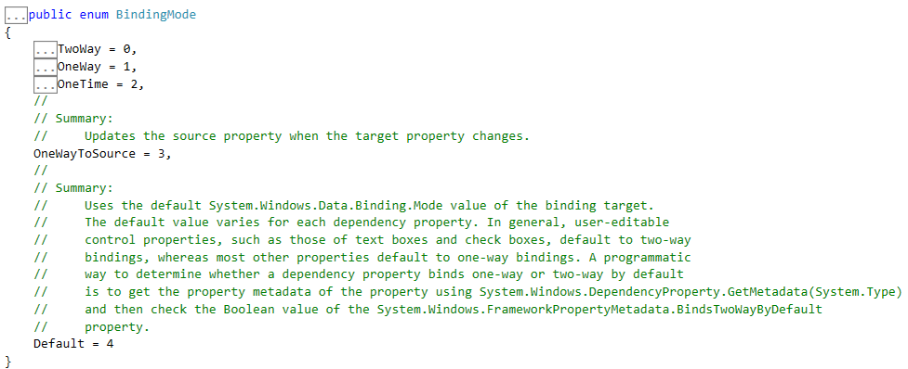

# RouteEvent

## Assembly and namespace

PresentationCore.dll

namespace System.Windows

## RoutedEvent

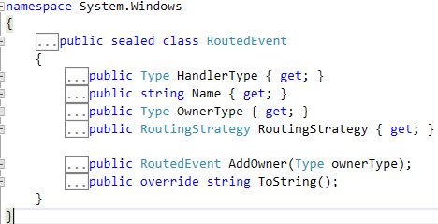

## RoutingStrategy

